**Arunachal Pradesh**

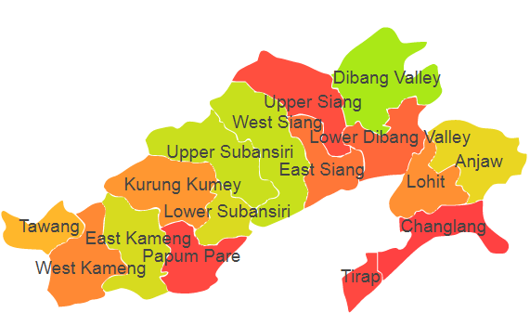

Arunachal Pradesh comprises of two Agro Ecological Regions (AER) namely 16 and 17.

**Agro-Eco Region 16 :** AER 16 in Arunachal Pradesh comprises of Along, Anini, Anjaw, Bomdila, Daporijo, Dibang Valley, East Kameng, East Siang, Khonsa, Kurung Kumey, Lohit, Lower Dibang Valley, Lower Subansiri, Papum-pare, Pasighat, Seppa, Tawang, Tezu,Upper Siang, Upper Subansiri,West Kameng,West Siang and Ziro districts of Eastern Himalayas under Agro Ecological Sub Region (AESR) 16.3.

**Agro-Eco Region 17 :** AER 17 in Arunachal Pradesh comprises of Changlang and Tirap

districts of North-eastern Hills under Agro Ecological Sub Region (AESR) 17.1.